**ECE 661-ARDUINO**

**Q. 1. What is Arduino board.**

Arduino is a project, open-source hardware, and software platform used to design and build electronic devices.

Arduino UNO includes 6 Analog pin inputs.

14 digital pins.

1 USB connector.

1 Power jack and

1 ICSP header.

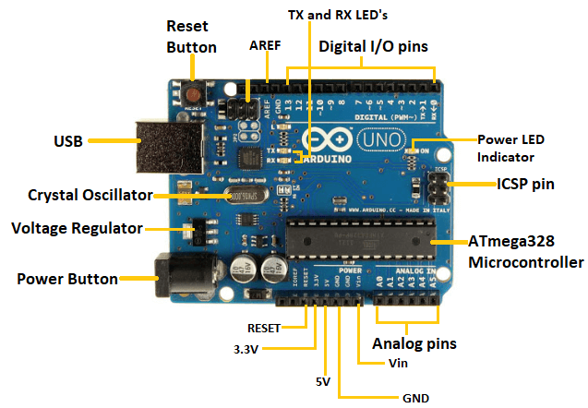

**Practical. 1. Interfacing 7 – Segment with Arduino board.**

**Practical. 2. Servo Moter.**

#include <Servo.h>

int pos = 0;

Servo servo_9;

void setup()

{

servo_9.attach(9, 500, 2500);

}

void loop()

{

for (pos = 0; pos <= 180; pos += 1) {

servo_9.write(pos);

delay(15);

}

for (pos = 180; pos >= 0; pos -= 1) {

servo_9.write(pos);

delay(15);

}

}

